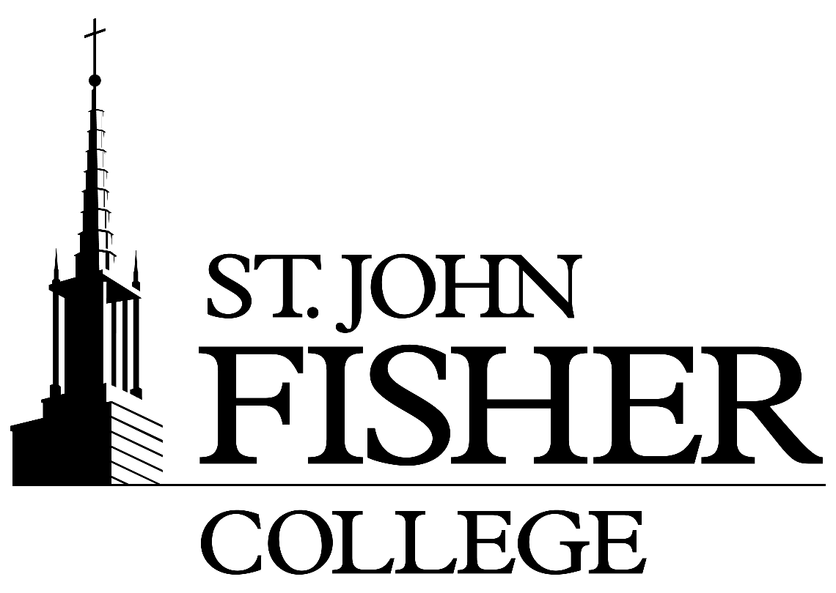
INTERNAL JOB APPLICATION PROCESS

Thank you for considering job opportunities within the College. The following guidelines have been provided to make this a more efficient process. Please feel free to contact the Human Resources Department at 385-8048 should you have any questions.

- Apply for a specific position at https://jobs.sjfc.edu or to apply for an internal posting only, please click on the link provided by HR.

- Complete the Internal Job Application form (attached)

- Sign the form

- Obtain Supervisor’s signature

- Take the completed form to the HR Dept (K211)

NOTE:
- To be eligible to participate in the job posting process you must be employed at your current position for at least one year, have a satisfactory work record, and be in good standing at your current position. Exceptions will require approval from the Director of Human Resources.

- Each employee interested in applying for an open position is encouraged to have a discussion with his or her current Supervisor/Manager about his or her interest in applying for the position. If you indicate an interest in a new position, your current position or status at the College will not be jeopardized.

- Internal candidates will be given preference in consideration over similarly qualified external candidates. In doing so, the College will always attempt to hire and/or promote from within teams or departments when current employees may possess comparable or greater qualifications.

INTERNAL JOB APPLICATION FORM

Name____________________________________________ Date_____________________

Current Department_________________________________ Hire date_________________

Current Supervisor__________________________________

Job Applying for____________________________________ Dept_____________________

Why are you looking to leave your current position? ________________________________________________________________________________________________________________________________________________________________________________________________________________________________________________________________________________________________

How long have you been in your current position? _________________________________________________________________________________________________________________

Your qualifications for the job including degrees, licenses: ________________________________________________________________________________________________________________________________________________________________________________________________________________________________________________________________________________________________

Are you related to or would you be considered a *¹ personal associate to anyone within the hiring department for which you are applying? _________________________________________________________________________________________________________________

_________________________________ ____________________________________
Employee Signature/Date *² Current Supervisor Signature/Date

*^{1”}Personal Associates” are defined as individuals with close personal relationships such as “romantic” or “dating” relationships.

*²My signature, as the current supervisor, signifies that I am aware of the employee’s candidacy for this position.

TO BE COMPLETED BY THE HIRING DEPARTMENT AND HUMAN RESOURCES

Date that application was received by HR ________________

Was employee interviewed? _____ Yes ______No

Date of interview __________

_________________________________ __________________________________
Human Resources Representative/Date Hiring Dept Representative/Date

